Note: Write code in handwritten form no theory needed.

Lab 1:
Source Code
from PIL import Image
# Open the image
img = Image.open("nature.jpg")
# Convert image to grayscale
gray_img = img.convert("L")
# Save the grayscale image
gray_img.save("gray_image.jpg")
print("Image converted to grayscale successfully")

Output:




Note: For theory based labs do in this format all printed.

lab : 07 Date: 2082/10/13
Title: Design Tools & Workflow

Objective: To compare any two UI/UX or graphic design tools that I used in my tasks with their features, advantage and limitations.
Theory:
Figma:
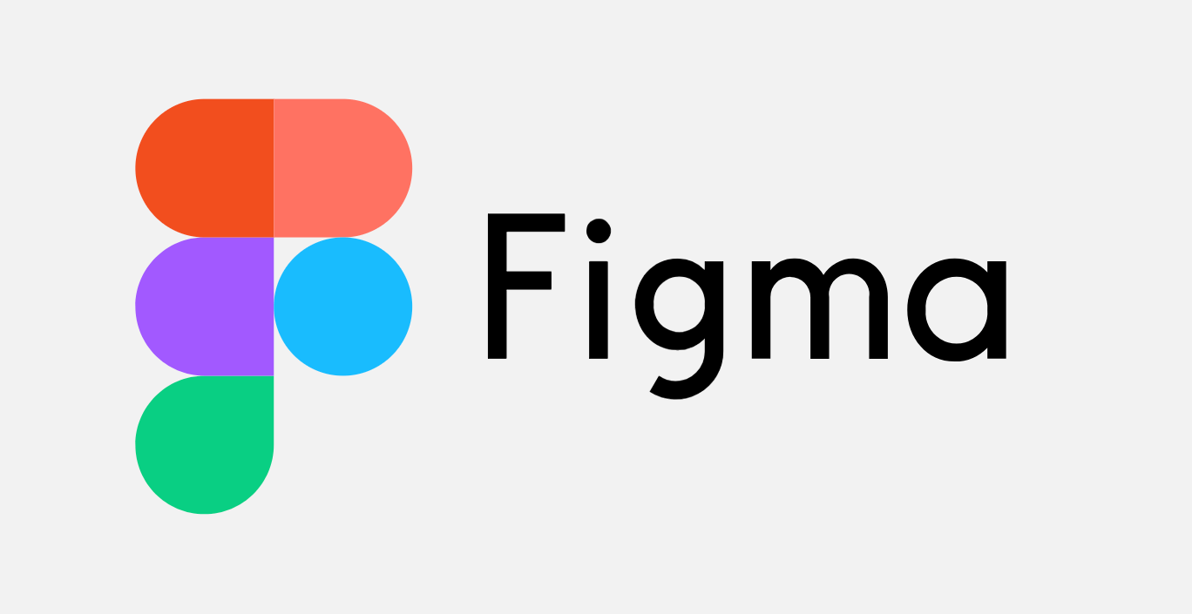
Figma is a collaborative web application for interface design,
with additional offline features enabled by desktop applications
for macOS and Windows. The feature set of Figma focuses on
user interface and user experience design, with an emphasis on
real-time collaboration, utilizing a variety of vector graphics editor
and prototyping tools. The Figma mobile app for Android and
iOS allows viewing and interacting with Figma prototypes in real-time
on mobile and tablet devices.

Features of figma:
- It supports real-time collaboration where multiple users can edit the same file simultaneously.
- It provides powerful UI/UX design tools for creating wireframes, layouts, and interfaces.
- It allows interactive prototyping with animations and transitions.
- It supports reusable components and design systems for consistency.
Advantages:
- Figma provides a shared workspace where designers, developers, and stakeholders can collaborate in real time using comments and notifications.
- Every change is automatically saved, allowing users to view version history and restore earlier designs when needed.
- Interactive prototypes can be created directly in Figma, helping teams test and improve usability quickly.
- A generous free plan and affordable paid options make Figma a cost-effective solution for teams of all sizes.
Conclusion

